Lesson 3: Conservation of Energy
Name: _______________________
In this lesson we introduce the law of conservation of energy using a variety of examples.
Example 1: The Pendulum
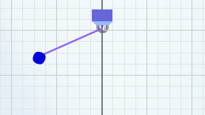
Consider the following pendulum, at what point will the pendulum move the fastest? ____________
Where is the pendulums gravitational potential the greatest? _________
Where is its gravitational potential energy the smallest? __________
Where is the pendulums kinetic energy the greatest? __________
Where is its kinetic energy the smallest? _________
What connections can you make between the pendulum’s kinetic and gravitational potential energy?

Example 2: The Toy Car
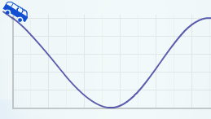
Consider the following toy car, at what point is the car moving the fastest? ____________
Where is the cars gravitational potential the greatest? _________
Where is its gravitational potential energy the smallest? __________
Where is the cars kinetic energy the greatest? __________
Where is its kinetic energy the smallest? _________
What connections can you make between the car’s kinetic and gravitational potential energy?

The observations you’ve made are the basic principal of the Law of Conservation of Energy: in a closed system, energy can be converted from one form to another, but the total amount of mechanical energy (Eg + Ek) remains the same at any point: E_{g1} + E_{k1} = E_{g2} + E_{k2}

Writing the total mechanical energy as E_{m}, we can also write the law of conservation of energy as:
E_{m} = E_{g} + E_{k}
Example 3: The Diver
Calculate the total mechanical energy in the system. The diver’s mass is 65kg.
Phase 1: Before the Dive | Phase 2: Halfway Point | Phase 3: Water’s Surface
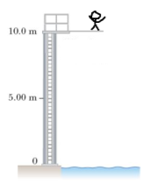 | 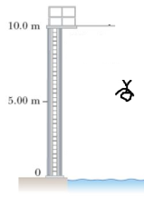 | 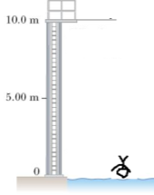
Calculation (E_{m} = E_{g}): | Calculation (E_{m} = E_{g} + E_{k}): | Calculation (E_{m} = E_{k}):

Work-Energy Theorem
The net amount of work done on an object equals the object’s change in total mechanical energy, which can be represented mathematically as:
W_{NET}= ΔE_{K} +ΔE_{g}

$$W_{NET}= \left(\frac{{mv}_{f}^{2}}{2}- \frac{{mv}_{i}^{2}}{2}\right)+ \left({mgh}_{f}- {mgh}_{i}\right)$$

For horizontal motion this equation simplifies to:
$$W_{NET}= \frac{{mv}_{f}^{2}}{2}- \frac{{mv}_{i}^{2}}{2}$$

Conservation of Energy Practice Problems

1. A 1.1 kg camera slips out of a photographer’s hands while taking a photograph. The camera falls 1.4 m to the ground below.
a) What is the camera’s gravitational potential energy, relative to the ground, when it is in the photographer’s hands?
b) Determine the kinetic energy of the camera, the instant it hits the ground.
c) At what speed is it travelling the instant the camera hits the ground?

2. For safety reasons, a roller coaster must have a minimum velocity of 10.0 m/s at the top of a loop to make it around safely. Assuming the roller coaster starts from rest at the top of the first hill, and there is no friction on the roller coaster, what is the minimum height of the hill needed to make it safely through a 16 m high loop?

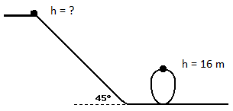

3. A pendulum with string of length 1 m is raised to an angle of 30°below the horizontal, as shown below, and then released. What is the velocity of the pendulum when it reaches the bottom of its swing?

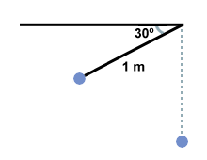

Answers: (1a) 15J (1b) 15J (1c) 5.2 m/s (2) 21 m (3) 3.1 m/s

